**NETFLIX STOCK PRICE ANALYSIS**

In this notebook, I will discover and explore data of Netflix stock price from 2002-2022 using the Time series analysis method. I will also predict future stock prices through Prophet. I use **SQL**, **Pandas**, and **Numpy**, **plotly** to get stock information and visualize different aspects of it using **Tableau**, **Seaborn**, **matplotlib**. In addition.

**Define problems**:

1. **What was the change in the price of stock over time?**

* The closing price is the last price at which the stock is traded during the regular trading day. A stock’s closing price is the standard benchmark used by investors to track its performance over time. So Close price will be used for analysis.
* In addition, the Relative Strength Index (RSI) should be considered. It is used in technical analysis to measure the speed and change of price movements. It is primarily employed to identify overbought or oversold conditions in a market, helping traders and analysts assess potential reversal points.

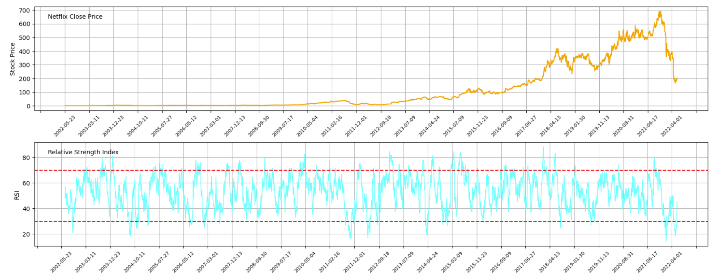

1. **What was the change in the Volume of stock over time?**

* The stock trading volume refers to the number of shares of security traded between its daily open and close. Trading volume, and changes in volume over time, are important inputs for technical traders.

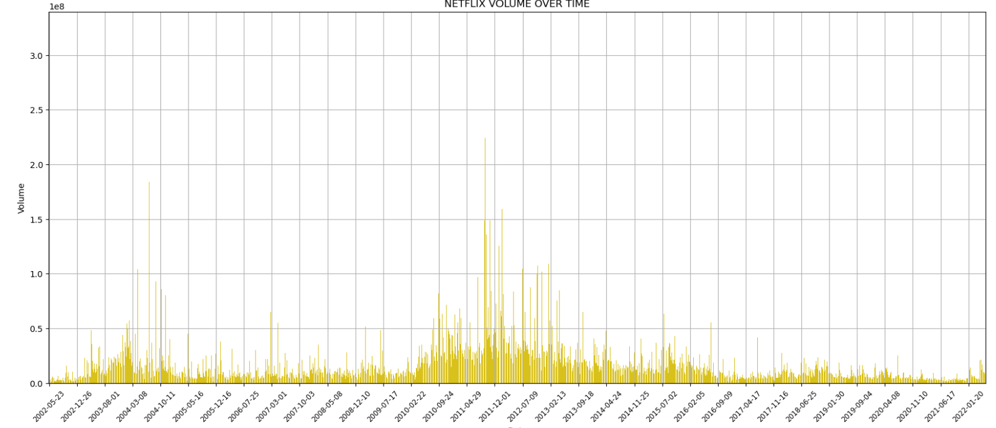

1. **What was the change in Market Capitalization of stock over time?**

* Market capitalization is a key metric used by investors, analysts, and financial professionals to assess the relative size of a company, compare it to other companies in the market, and make investment decisions.

Daily Market Capitalization = Open Price * Volume

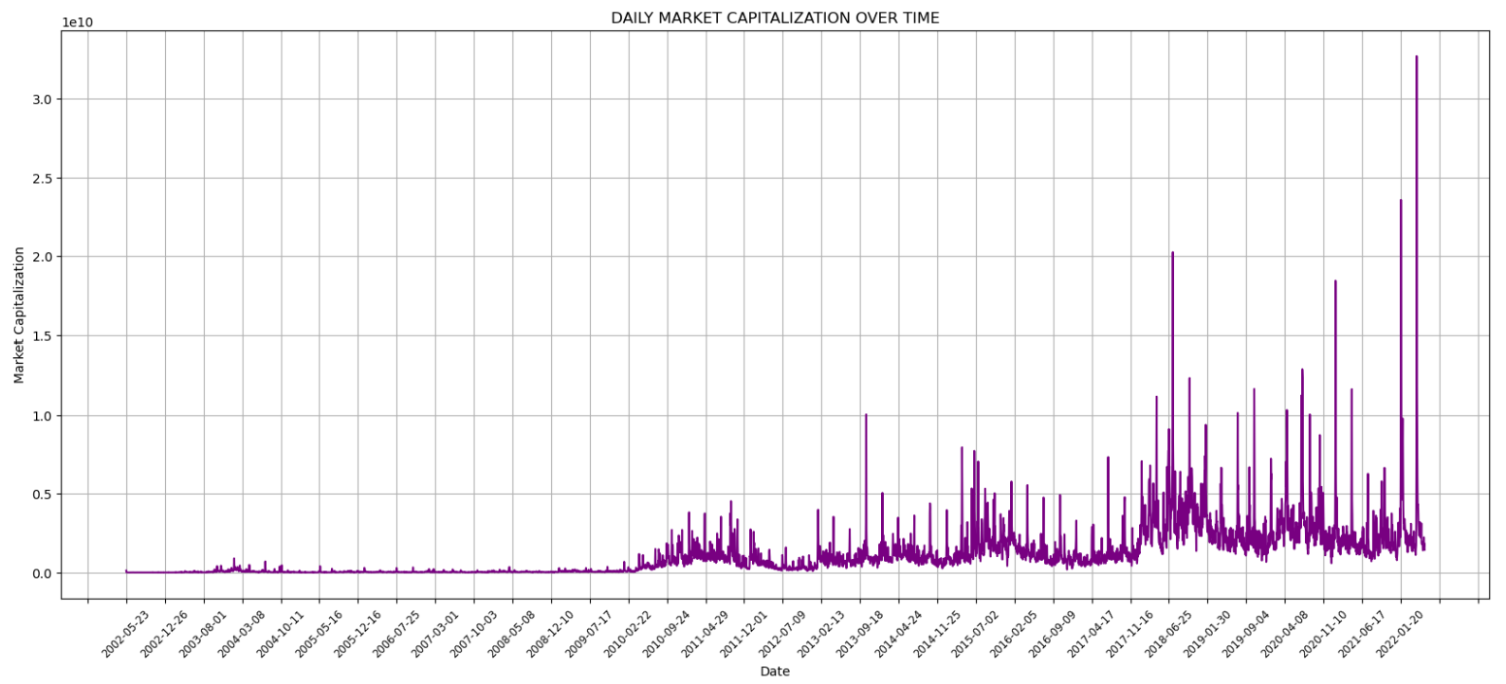

1. **What was the daily return (volatility) of stock on average?**

* Daily return represents the percentage change in the value of a financial instrument from one trading day to the next. It reflects the daily profit or loss of an investment. Daily returns are crucial for assessing the performance and risk of a stock. Daily returns are used to calculate metrics like average daily/ monthly/ yearly/ weekday returns…

Daily Return = (Close Price 1 / Close price 0) -1

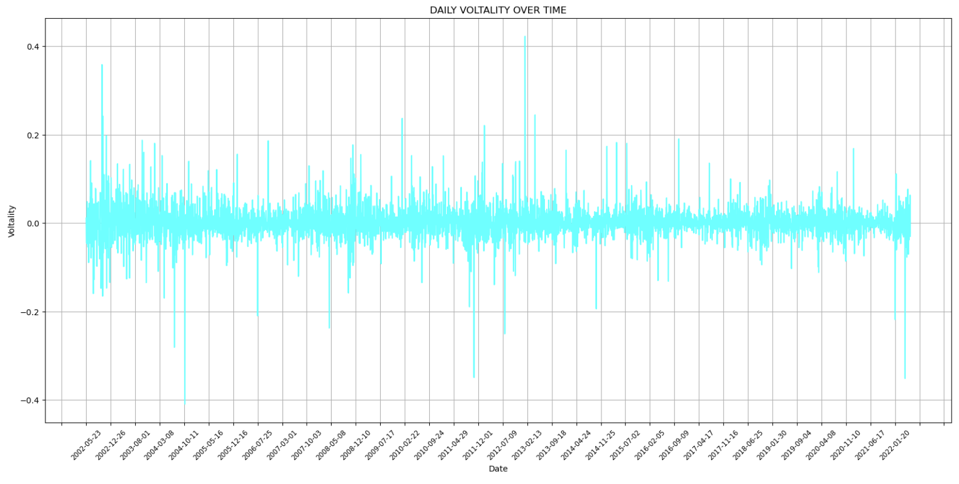

* 1. **The Average Monthly Returns**

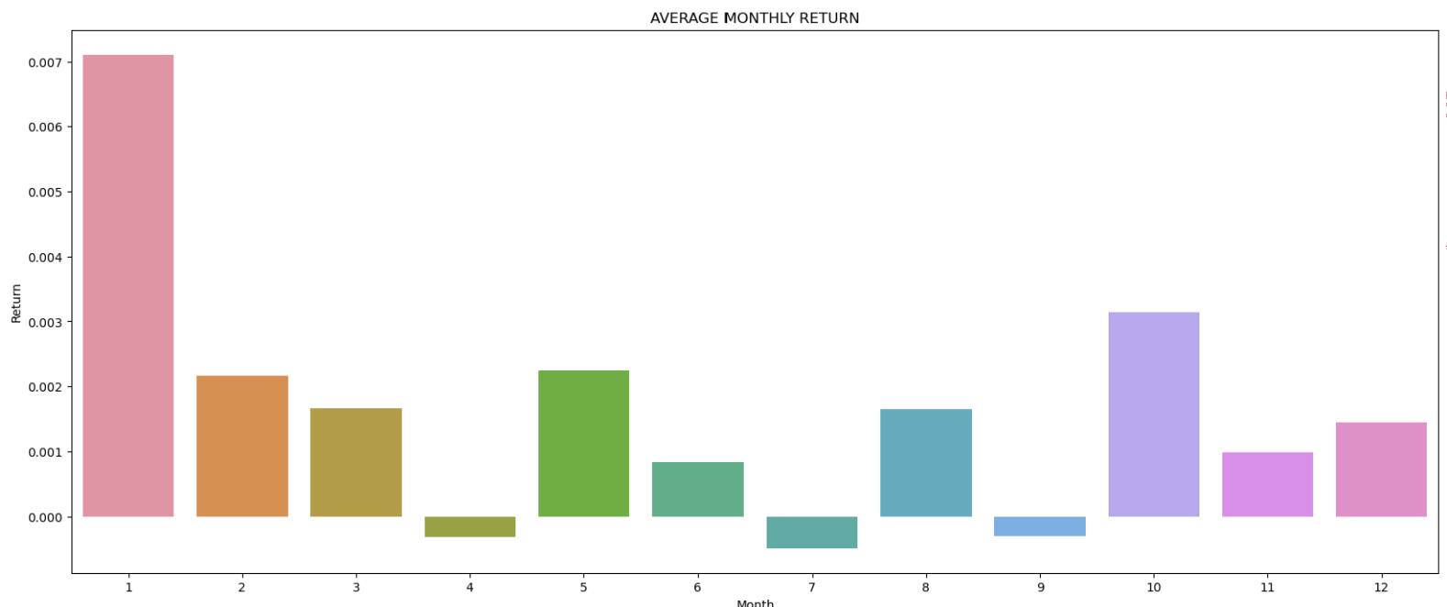

* 1. **The Average Yearly Returns**

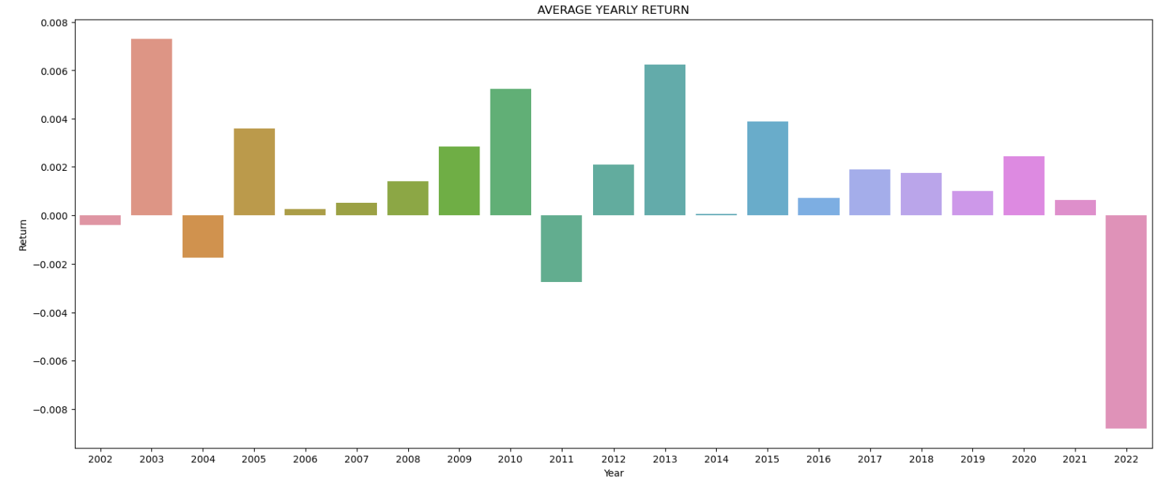

* 1. **The Average Day of Week Returns**

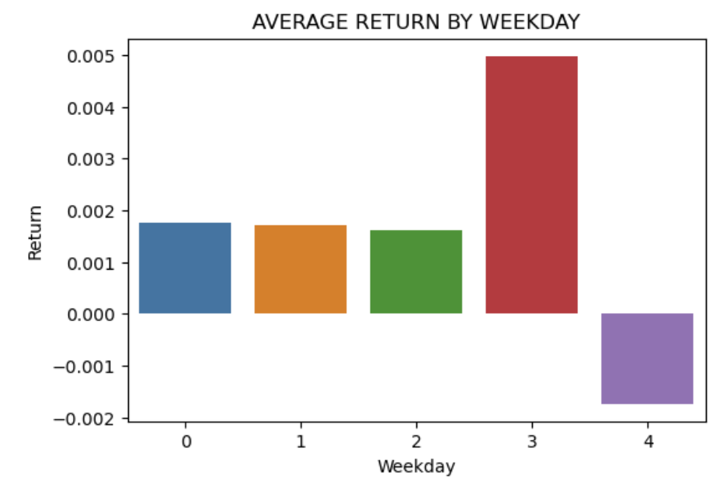

1. **Cumulative Return using Close Price & Adjusted Close Price**

* Investors and analysts use cumulative returns to assess the overall performance of an investment over a specific period. It provides insights into the total percentage gain or loss, considering the compounding effect of daily returns.
* A positive cumulative return indicates a profit.
* A negative cumulative return indicates a loss.
* A cumulative return of 0% means no change in value.

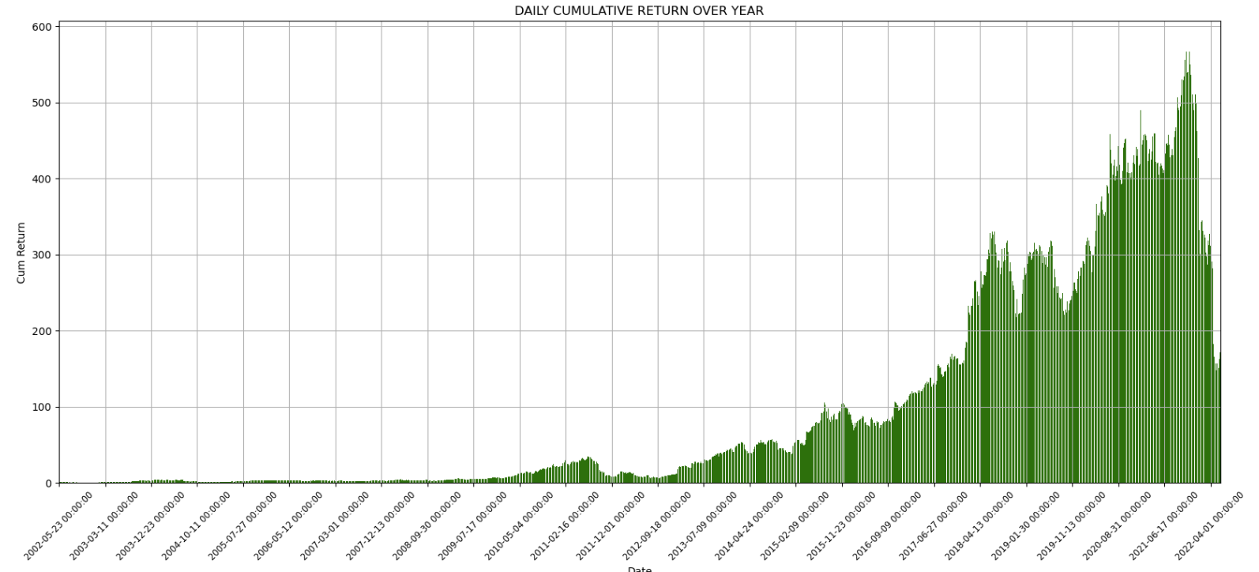

1. **What was the moving average of stock?**

* A moving average is used to analyze data points by creating a series of averages of different subsets of the full data set. In the context of stock market analysis, a moving average is often used to smooth out fluctuations in stock prices over a specific period like 10 days, 20 days, 50 days, 100 days, making it easier to identify trends.

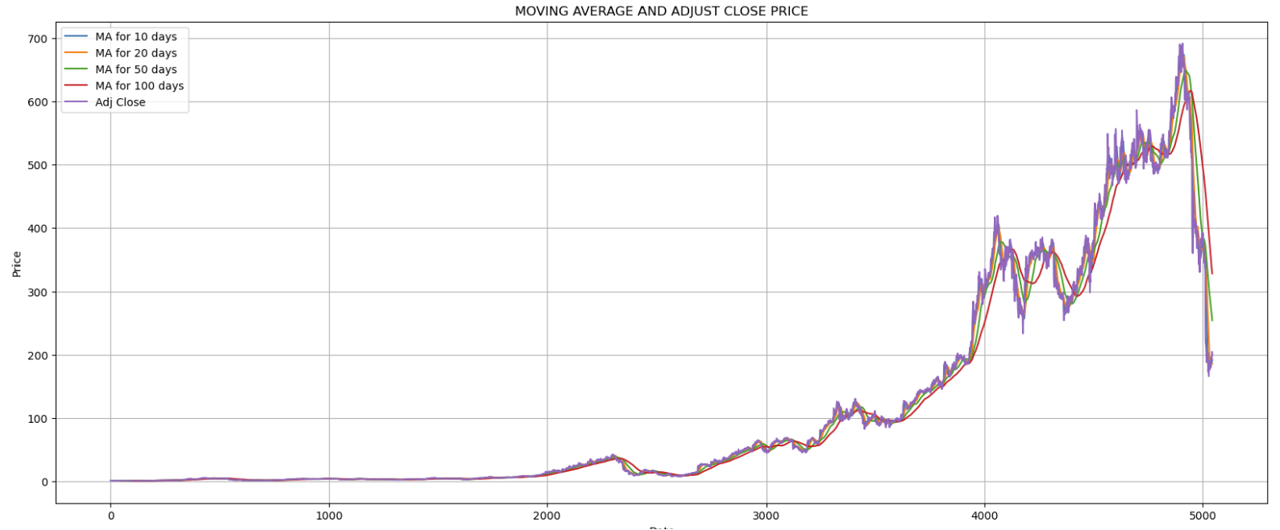

1. **Predicting the closing price stock price of Netflix using LSTM**

* ***What is the Prophet?***
* Prophet is a time-forecasting algorithm developed by the Facebook team. The model is designed to make time predictions based on data that has specific characteristics such as daily and annual seasonal trends, holiday effects, and the possible impact of certain events.
* ***I will forecast the stock price in 3650 days. How to do that?***
* Define Split Date: Which date will we split data into train_data and test_data?
* Define train_data & test_data based on Split Date
* Define Forecast period: 3650 days
* Define which model you will use to make a forecast. In this case, we will use Prophet: model=Prophet()
* Fit model with historical stock data

